Statewide Safety, Protection & Wellbeing Programme Analytics Dashboard
Madhya Pradesh | KGBVs & NSCBAVs
Case Study Project Title:
Statewide Safety, Protection & Wellbeing Programme — Data Analytics & Impact Monitoring Solution
Technology: Power BI | Power Query | DAX | Data Modeling

1. Project Overview
Meri Suraksha Mere Adhikar — Safety & Protection Learning Impact Dashboard
Project Type: Data Analytics & Business Intelligence
Domain: Education, Child Safety & Learning Impact Measurement
Technology: Microsoft Power BI, Power Query, DAX, Excel/Forms-based assessment data
Geography: Madhya Pradesh
Reporting Hierarchy: State → District → Institution
Meri Suraksha Mere Adhikar (My Safety, My Rights) is a statewide safety and protection training programme designed to improve awareness among students and hostel personnel regarding unsafe situations, protective behaviours, and available support mechanisms.
The project involved designing an interactive Power BI analytics and reporting solution to monitor programme implementation and measure learning outcomes across institutions. The dashboard brings together assessment, demographic, institutional and training-related data into a structured reporting model.
A key component of the solution is pre- and post-assessment analysis, allowing stakeholders to examine changes in learner performance and calculate learning gain after training. The dashboard is structured across multiple administrative levels so that users can move from a statewide view to district-level and institution-level analysis.
The reporting framework was designed around three major levels:
- State Level — overall programme coverage, district performance and learning outcomes
- District Level — institution-wise performance, completion and areas requiring attention
- Institution Level — student performance, module-level outcomes and training progress
The solution therefore moves beyond simply displaying assessment scores and provides a framework for monitoring programme coverage, evaluating learning impact and identifying areas requiring follow-up.

2. Problem Statement
The programme generated assessment and training information through Excel and Forms-based data sources, but the information was not available through a unified analytical reporting system. This created challenges for stakeholders who needed to monitor programme implementation and learning outcomes across districts and institutions.
The major challenges were:
1. Lack of centralized reporting
Assessment data was distributed across raw Excel/Forms exports, making it difficult to obtain a consolidated view of programme performance.
2. Limited visibility into programme progress
Stakeholders needed to understand programme coverage across districts and institutions, including training and assessment completion.
3. Difficulty measuring learning improvement
Pre- and post-assessment data needed to be connected at the student level to determine whether learning and awareness improved after training.
4. Limited institution and district-level analysis
A statewide aggregate alone could not identify where performance gaps existed. Stakeholders required the ability to drill from State → District → Institution.
5. Difficulty identifying performance gaps
Without integrated analytical views, it was difficult to identify differences in performance across modules, competencies, institutions and learner groups.
6. Need for actionable monitoring
Programme administrators required a dashboard that could move from “What is happening?” to “Where does attention need to be focused?” through completion tracking, performance analysis and institutional action points.

Page 1 — Programme Overview Dashboard

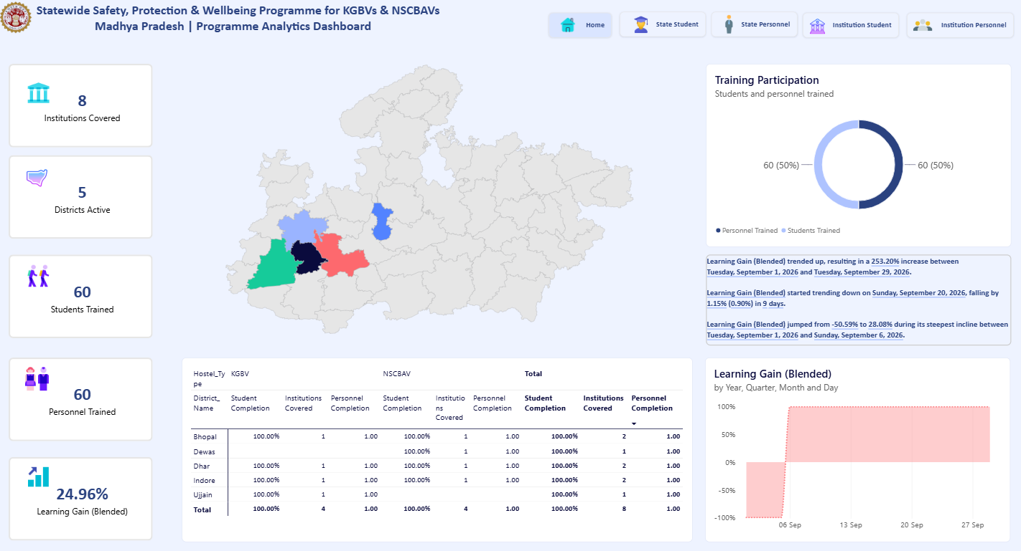

Page Objective
The Programme Overview Dashboard provides a consolidated state-level view of the Safety, Protection & Wellbeing Programme across KGBVs and NSCBAVs in Madhya Pradesh.
The page is designed to help programme stakeholders quickly understand programme coverage, training participation, institutional reach and overall learning impact, while providing geographic and trend-based context for further analysis.
Key Business Questions
This page answers:
- How many institutions are currently covered?
- How many districts are actively participating?
- How many students and personnel have been trained?
- What is the overall learning gain after training?
- How is training participation distributed between students and personnel?
- How is programme coverage distributed across districts and hostel types?
- How is learning gain changing over time?

Key KPIs
KPI | Purpose
Institutions Covered | Tracks the number of institutions included in the programme
Districts Active | Shows the geographic reach of the programme
Students Trained | Measures student participation
Personnel Trained | Measures participation of institutional personnel
Learning Gain (Blended) | Indicates the overall change between pre- and post-assessment performance
The KPI cards provide an immediate executive-level snapshot before users move into the detailed visuals.

Visuals & Their Purpose
1. Madhya Pradesh Map — Geographic Coverage
The state map provides a geographical view of programme activity across Madhya Pradesh.
Purpose:
To help stakeholders understand where the programme is currently active and identify districts with recorded programme activity.
Interaction:
Selecting a district on the map can filter the other visuals on the page, allowing users to explore the selected geographic area.

2. Training Participation — Students vs Personnel
The donut chart compares participation between:
- Students Trained
- Personnel Trained
Purpose:
Provides a quick view of how training participation is distributed across the two major beneficiary groups.

3. District & Hostel-Type Summary
The matrix provides a more detailed breakdown across:
- District
- Hostel Type — KGBV / NSCBAV
- Student Completion
- Institutions Covered
- Personnel Completion
Purpose:
Allows stakeholders to compare programme coverage and completion across districts and hostel types.
This complements the map by providing the actual tabular values behind the geographic view.

4. Learning Gain Trend
The Learning Gain (Blended) chart presents learning-gain movement over time using year, quarter, month and day.
Purpose:
Helps stakeholders examine how the measured learning outcome changes over the reporting period.
The use of a date hierarchy also allows the analysis to move between broader and more granular time periods.

5. Insight / Trend Summary
The insight panel automatically surfaces notable changes in the Learning Gain (Blended) metric.
Purpose:
Instead of requiring users to manually interpret the trend, the panel highlights significant movements in the metric and provides additional analytical context.

KPI Cards — Programme Overview

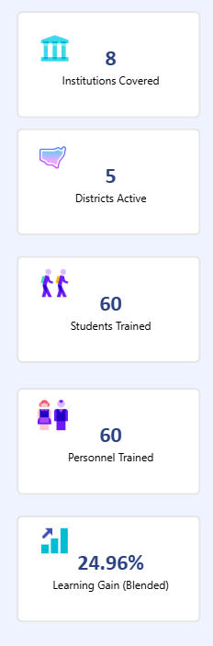

The left-side KPI section provides a quick snapshot of the programme's current coverage, participation and measured learning impact.
KPI | Current Value | What It Measures
Institutions Covered | 8 | Number of institutions currently covered by the programme
Districts Active | 5 | Number of districts with programme activity
Students Trained | 60 | Number of students who participated in the training
Personnel Trained | 60 | Number of hostel/institutional personnel trained
Learning Gain (Blended) | 24.96% | Overall measured improvement between the relevant pre- and post-assessment results

Visual: Madhya Pradesh District Map

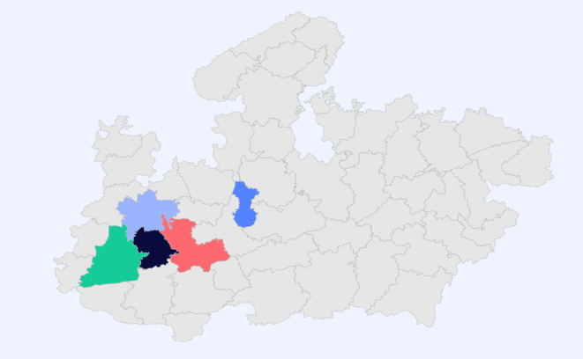

Purpose
The map provides a geographical view of programme activity across Madhya Pradesh, showing the districts where the programme currently has recorded coverage/activity.
Why it is used on this page
As the Programme Overview / State-level dashboard, the map gives stakeholders an immediate understanding of the programme's geographical reach. It complements the KPI cards by answering not only how many districts are active, but also where the activity is concentrated.
It also provides a visual foundation for moving from the state-level overview to district-level analysis.
What happens when clicked
When a user clicks a highlighted district on the map:
- The selected district becomes the active filter/context.
- Other visuals on the page, such as training participation, district summary and learning-gain analysis, are filtered according to the selected district, subject to the dashboard's configured interactions.
- This allows the user to examine the programme's performance for a specific geographic area without manually applying a district slicer.

Visual: Training Participation

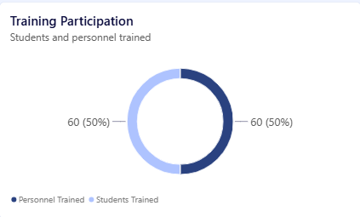

Purpose
The Training Participation donut chart shows the distribution of trained participants between the two primary programme groups:
- Students Trained — 60
- Personnel Trained — 60
The current view therefore shows an equal 50%–50% distribution.
Why it is used on this page
This visual is included on the Programme Overview dashboard to provide a quick comparison of programme participation across its two key beneficiary groups. It complements the individual Students Trained and Personnel Trained KPI cards by presenting their relationship visually rather than only as separate numbers.
It helps stakeholders quickly understand who is being reached by the programme and whether participation is balanced between students and personnel.
What happens when clicked
When a user clicks either segment of the donut:
- The selected category (Students Trained or Personnel Trained) becomes the active selection.
- Other visuals on the page are cross-filtered/highlighted according to the configured Power BI interactions.
- This allows the user to explore the corresponding participant category across the available dashboard data.

Visual: District & Hostel-Type Performance Matrix

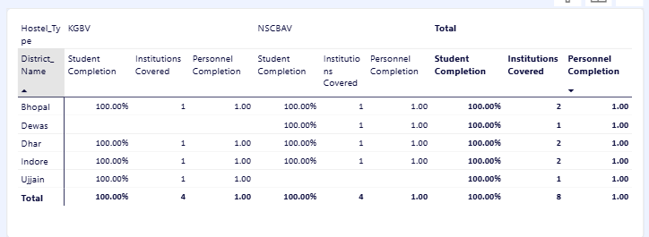

Purpose
The matrix provides a detailed district-level breakdown of programme coverage and completion across the two hostel types — KGBV and NSCBAV.
It brings together student completion, institutions covered and personnel completion in a single comparative view.
Why it is used on this page
The dashboard's other visuals provide a high-level picture through KPIs, the map and the participation donut. This matrix adds the underlying detailed figures, allowing stakeholders to move from a high-level state view to a district-wise operational view.
It helps answer:
- Which districts have programme activity?
- How many institutions are covered in each district?
- How does coverage differ between KGBV and NSCBAV?
- What is the student completion status?
- What is the personnel completion status?
- What is the overall coverage across both hostel types?
What the Matrix Shows
The matrix is organized hierarchically:
Hostel Type → District → Programme Metrics
For each district, it displays:
- Student Completion
- Institutions Covered
- Personnel Completion
These measures are presented separately for:
- KGBV
- NSCBAV
- Total
The Total columns provide the consolidated view across both hostel types.
What Happens When Clicked
When a user selects a district row or a particular value within the matrix:
- The selected district/category interacts with other visuals on the dashboard according to the configured Power BI relationships.
- Other visuals can be filtered or highlighted to reflect the selected district.
- This allows users to move from the consolidated state-level view toward a more focused district-level analysis.

Visual: Learning Gain (Blended) Trend

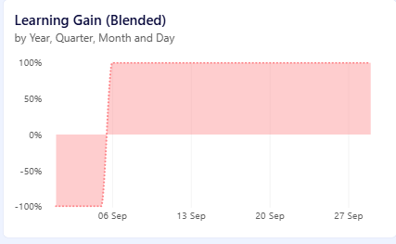

Purpose
The Learning Gain (Blended) chart tracks the change in learning performance over time by comparing the relevant pre- and post-assessment results.
Why it is used on this page
This visual is included to complement the Learning Gain (Blended) KPI. While the KPI provides a single overall figure, the trend chart adds a time dimension, helping stakeholders understand how learning outcomes are changing across the reporting period.
It provides context for the overall programme effectiveness and helps identify significant movements or changes in measured learning gain.
What the Visual Shows
The chart uses a date hierarchy:
Year → Quarter → Month → Day
This allows users to move between different levels of time-based analysis.
The percentage axis represents the Learning Gain (Blended) measure, making it possible to observe both positive and negative movements in the metric.
What Happens When Clicked
When a user selects a point or period on the trend:
- The selected date/period becomes the active filter or selection.
- Other visuals on the page can be cross-filtered or highlighted based on the configured interactions.
- Users can therefore investigate the corresponding programme participation and performance for that period.

Page 2 — State Student Analytics

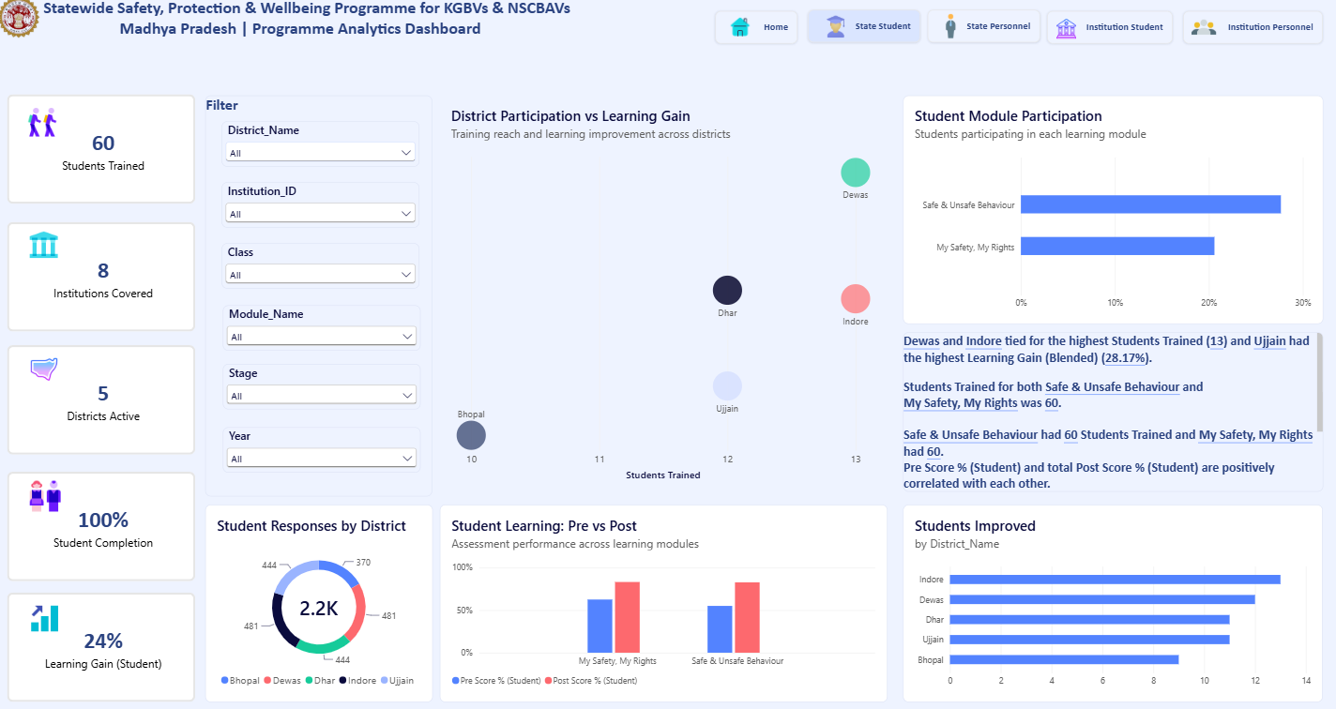

This page provides a state-level overview of student participation, completion and learning outcomes across districts and institutions. It enables users to analyze student performance through pre- vs post-assessment scores, learning gain, module participation and district-wise improvement.
Interactive filters for district, institution, class, module, assessment stage and year allow users to perform focused analysis and understand how student outcomes vary across different programme segments.
Key focus:
Student Reach → Participation → Pre vs Post Performance → Learning Gain → District-wise Improvement

Visual: Student Analytics Filter Panel

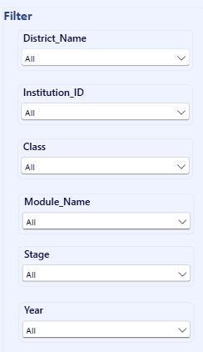

Purpose:
The filter panel enables users to dynamically narrow the student analysis based on specific programme dimensions.
Why it is used:
It allows stakeholders to move from the overall state-level view to a focused analysis of a particular district, institution, class, module, assessment stage or year.
Available Filters:
- District Name — analyze a specific district
- Institution ID — focus on an individual institution
- Class — analyze a particular class
- Module Name — focus on a learning module
- Stage — compare/filter assessment stages
- Year — analyze a specific reporting year
What happens when selected:
Selecting any filter dynamically updates the connected KPI cards, charts and analytical insights on the page according to the selected context.

Visual: District Participation vs Learning Gain

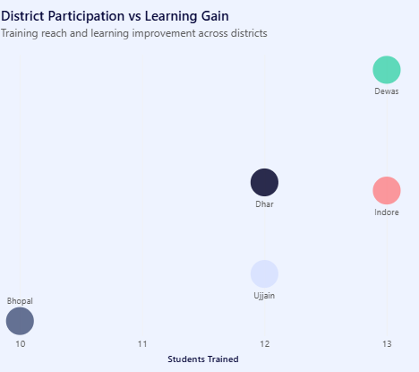

Purpose
The District Participation vs Learning Gain visual is designed to compare student training reach with learning improvement across districts. Each bubble represents a district, allowing users to view student participation alongside the corresponding learning-gain measure.
The visual currently includes Bhopal, Dewas, Dhar, Indore and Ujjain, with the horizontal axis representing Students Trained and the vertical position representing Learning Gain.
Why It Is Used on This Page
This visual is used to connect two important dimensions of programme performance:
- Programme Reach — measured through the number of students trained.
- Learning Impact — measured through learning gain.
A simple participation chart would only show how many students were trained, while a learning-gain chart would only show outcome. By combining both measures, the visual allows stakeholders to examine participation and learning outcomes together at district level.
It is particularly useful for identifying patterns such as:
- Districts with higher student participation and higher learning gain.
- Districts with similar participation but different learning outcomes.
- Districts with lower participation that may require further investigation.
- Potential differences in programme outcomes across participating districts.
How to Read the Visual
Each bubble represents one district.
- X-axis: Students Trained
- Y-axis: Learning Gain
- Bubble: Individual district
- District label: Identifies the corresponding district
For example, the current visual shows districts such as Dewas, Indore, Dhar, Ujjain and Bhopal positioned according to their student participation and learning-gain values.
What Happens When Clicked
When a user clicks a district bubble:
- The selected district is highlighted.
- Other visuals on the page can be cross-filtered or highlighted according to the configured Power BI interactions.
- The user can therefore examine the selected district's student participation, module participation, assessment performance and improvement metrics in greater detail.
- Combined with the page filters, this allows users to move from a state-level comparison to a focused district analysis..

Visual: Student Module Participation

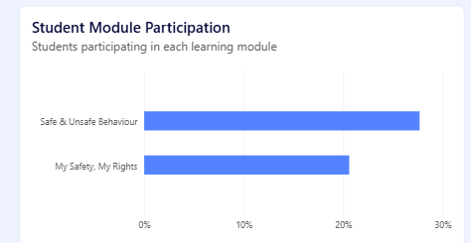

Purpose
The Student Module Participation bar chart shows the proportion of students participating in each learning module. It provides a direct comparison of student reach across the different modules included in the programme.
Why It Is Used on This Page
This visual is included to understand module-wise participation rather than looking only at the overall number of students trained.
It helps stakeholders identify:
- Which modules have greater student participation.
- Whether participation is consistent across learning modules.
- Potential differences in module coverage that may require further investigation.
In the current view, Safe & Unsafe Behaviour has a higher participation percentage than My Safety, My Rights.
What Happens When Clicked
When a user selects a module bar:
- The selected module is highlighted.
- Other connected visuals can be cross-filtered or highlighted based on the configured Power BI interactions.
- Users can then examine the selected module's assessment performance and learning outcomes in greater detail.

Visual: Student Responses by District

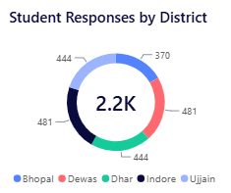

Purpose
The Student Responses by District donut chart shows the distribution of student assessment responses across the participating districts. The centre of the chart displays the total response volume (2.2K), while the individual segments represent the contribution from each district.
Why It Is Used on This Page
This visual provides a quick understanding of how assessment responses are distributed geographically.
It helps stakeholders:
- Compare response volumes across districts.
- Understand the contribution of each district to the overall assessment dataset.
- Identify districts with relatively higher or lower response participation.
- Complement the district-level learning and participation visuals with a view focused specifically on assessment responses.
The visual therefore helps distinguish assessment response coverage from simply looking at the number of students trained.
What Happens When Clicked
When a user clicks a district segment:
- The selected district is highlighted.
- Other connected visuals on the page can be cross-filtered or highlighted according to the configured Power BI interactions.
- The user can then examine the selected district's student participation, module performance, learning gain and improvement metrics

Visual: Student Learning — Pre vs Post

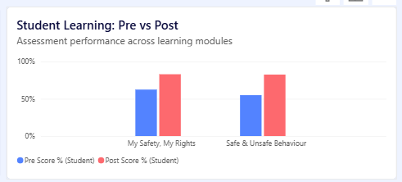

Purpose
The Student Learning: Pre vs Post clustered column chart compares student assessment performance before and after the training programme across the two learning modules:
- My Safety, My Rights
- Safe & Unsafe Behaviour
It presents the Pre Score % and Post Score % side by side for each module.
Why It Is Used on This Page
This is a key outcome visual because it directly evaluates student learning improvement following the training.
The comparison helps stakeholders understand:
- How students performed before the training.
- How students performed after the training.
- The change in performance across each learning module.
- Whether the programme is associated with an improvement in measured assessment performance.
- Which modules show a larger difference between pre- and post-assessment scores.
In the current view, the post-assessment bars are higher than the pre-assessment bars for both modules, indicating an improvement in the measured scores.
What Happens When Clicked
When a user selects a module or assessment bar:
- The selected module is highlighted.
- Other connected visuals can be cross-filtered or highlighted according to the configured Power BI interactions.
- Users can combine the selection with the page filters to examine the performance of a specific district, institution, class, year or assessment stage.

Visual: Students Improved by District

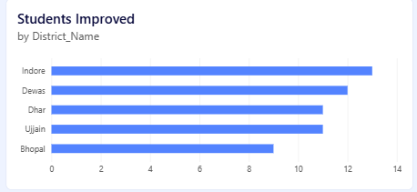

Purpose
The Students Improved bar chart shows the number of students demonstrating improvement in their assessment performance across participating districts.
The horizontal bars provide a direct district-wise comparison of the measured student improvement.
Why It Is Used on This Page
This visual is used to provide a district-level view of learning outcomes. While the Student Learning: Pre vs Post chart compares overall assessment performance across modules, this visual focuses specifically on where student improvement is being observed.
It helps stakeholders:
- Compare student improvement across districts.
- Identify districts with higher or lower numbers of improved students.
- Understand the geographic distribution of learning outcomes.
- Support further investigation when combined with participation and learning-gain metrics.
In the current view, Indore has the highest number of students improved, followed by Dewas, Dhar, Ujjain and Bhopal.
What Happens When Clicked
When a district bar is selected:
- The selected district is highlighted.
- Other connected visuals can be cross-filtered or highlighted according to the configured Power BI interactions.
- Users can then examine the selected district's module participation, pre- vs post-assessment performance and learning gain.

Page 3 — State Personnel Analytics

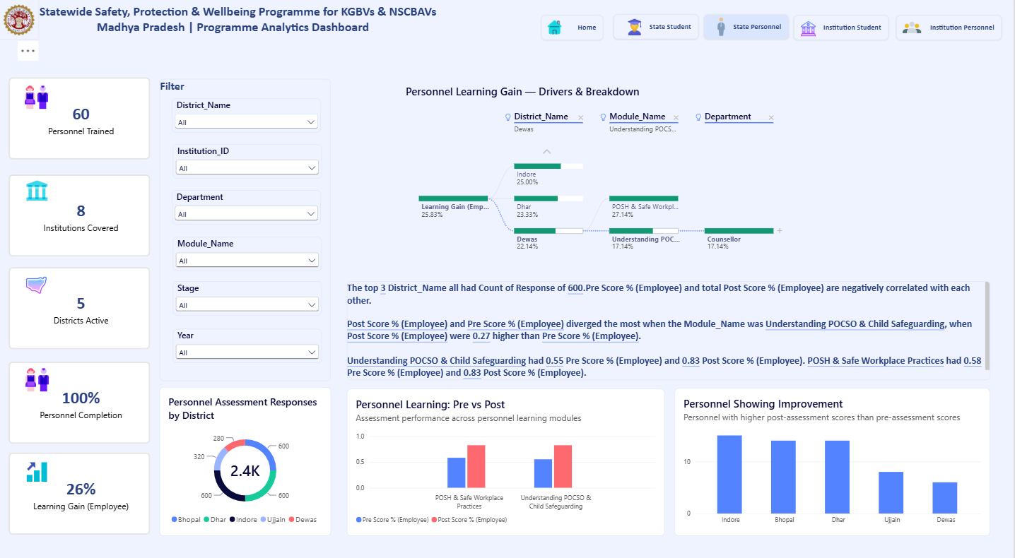

Page Overview
The State Personnel Analytics page provides a state-level view of personnel participation, assessment performance and learning outcomes across districts and learning modules.
The page focuses on evaluating personnel learning through pre- vs post-assessment performance, identifying personnel showing improvement, and analysing learning-gain drivers across district, module and department. Interactive filters allow the analysis to be narrowed by district, institution, department, module, assessment stage and year.
Key focus:
Personnel Reach → Assessment Performance → Learning Gain → Improvement → Drivers & Breakdown

Visual: Personnel Learning Gain — Drivers & Breakdown

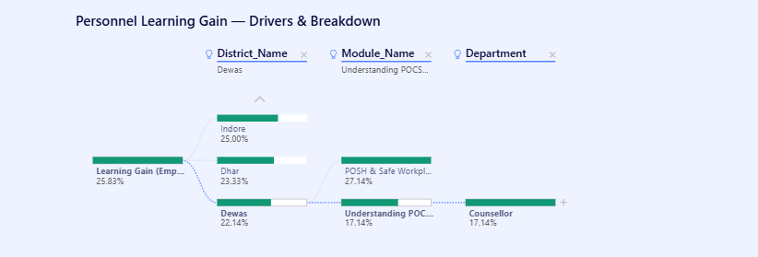

Purpose
The Personnel Learning Gain — Drivers & Breakdown visual provides a hierarchical analysis of the factors contributing to personnel learning gain. It breaks down the overall learning-gain measure across district, learning module and department dimensions.
Why It Is Used on This Page
This visual is used to move beyond the overall Learning Gain (Employee) KPI and understand which segments contribute to the observed learning outcome.
It helps stakeholders analyse learning gain through multiple dimensions:
- District — identifies differences in learning outcomes across locations.
- Module — shows how learning gain varies across personnel training modules.
- Department — provides a further breakdown of outcomes by personnel role/department.
The decomposition structure makes it possible to progressively drill into the data and identify the segments associated with different learning-gain values.
How the Visual Works
The analysis starts with the overall Learning Gain (Employee) measure and progressively breaks it down through selected dimensions.
For example:
Learning Gain → District → Module → Department
The displayed values show the learning-gain contribution/measure at each level of the breakdown.
What Happens When Clicked
When a user selects a node in the decomposition tree:
- The selected dimension becomes the next analytical breakdown.
- Users can drill further into the hierarchy to investigate the selected segment.
- The analysis can move from a broad state-level measure to a specific district, module or department.
- The selected context can also interact with other connected visuals on the page, depending on the configured Power BI interactions.

Visual: Personnel Assessment Responses by District

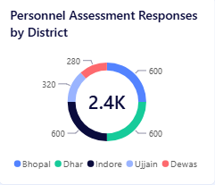
Purpose
The Personnel Assessment Responses by District donut chart shows the distribution of personnel assessment responses across the participating districts. The centre of the chart displays the total response volume of approximately 2.4K, while the individual segments represent the contribution from each district.
Why It Is Used on This Page
This visual provides a quick view of personnel assessment participation and response distribution across districts.
It helps stakeholders:
- Compare personnel response volumes across districts.
- Understand the geographic distribution of the assessment dataset.
- Identify districts contributing relatively higher or lower response volumes.
- Complement the personnel learning and improvement visuals with a measure of assessment participation.
This is particularly useful because the page analyses not only personnel learning outcomes but also the coverage of personnel assessment data behind those outcomes.
What Happens When Clicked
When a user selects a district segment:
- The selected district is highlighted.
- Connected visuals can be cross-filtered or highlighted according to the configured Power BI interactions.
- Other personnel visuals can then be viewed in the context of the selected district, including Pre vs Post performance, learning gain and personnel improvement.

Visual: Personnel Learning — Pre vs Post

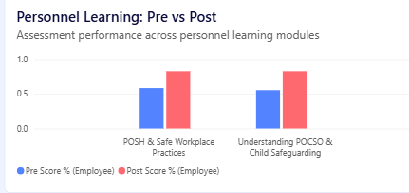
Purpose
The Personnel Learning: Pre vs Post clustered column chart compares personnel assessment performance before and after training across the two personnel learning modules:
- POSH & Safe Workplace Practices
- Understanding POCSO & Child Safeguarding
It displays Pre Score % (Employee) and Post Score % (Employee) side by side for each module.
Why It Is Used on This Page
This visual is used to evaluate the learning impact of personnel training by directly comparing assessment performance before and after the programme.
It helps stakeholders:
- Assess personnel performance before training.
- Measure changes in performance after training.
- Compare learning improvement across personnel modules.
- Identify modules where the difference between pre- and post-assessment scores is more pronounced.
In the current view, the post-assessment score is higher than the pre-assessment score for both modules, indicating an improvement in measured assessment performance.
What Happens When Clicked
When a user selects a module or assessment bar:
- The selected module is highlighted.
- Connected visuals can be cross-filtered or highlighted according to the configured Power BI interactions.
- The result can be further analysed using the page filters for district, institution, department, stage and year.

Visual: Personnel Showing Improvement

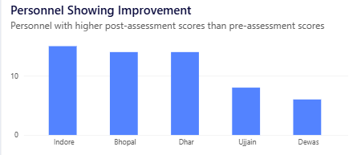

Purpose
The Personnel Showing Improvement bar chart shows the number of personnel whose post-assessment score is higher than their pre-assessment score, broken down by district.
Why It Is Used on This Page
This visual provides a direct district-level view of personnel learning improvement. While the Personnel Learning: Pre vs Post chart compares average assessment performance across modules, this visual focuses on the number of individual personnel showing improvement.
It helps stakeholders:
- Compare personnel improvement across districts.
- Identify districts with higher or lower numbers of personnel showing improvement.
- Understand the geographic distribution of personnel learning outcomes.
- Complement the overall Learning Gain (Employee) KPI with a more granular district-level measure.
In the current view, Indore has the highest number of personnel showing improvement, followed by Bhopal and Dhar, while Ujjain and Dewas show lower counts.
What Happens When Clicked
When a district bar is selected:
- The selected district is highlighted.
- Other connected visuals can be cross-filtered or highlighted according to the configured Power BI interactions.
- Users can further analyse the selected district's personnel assessment performance, learning modules and learning gain.
- Page filters can be combined with the selection to investigate a specific institution, department, module, stage or year.

Page 4 — Institution Student Analytics

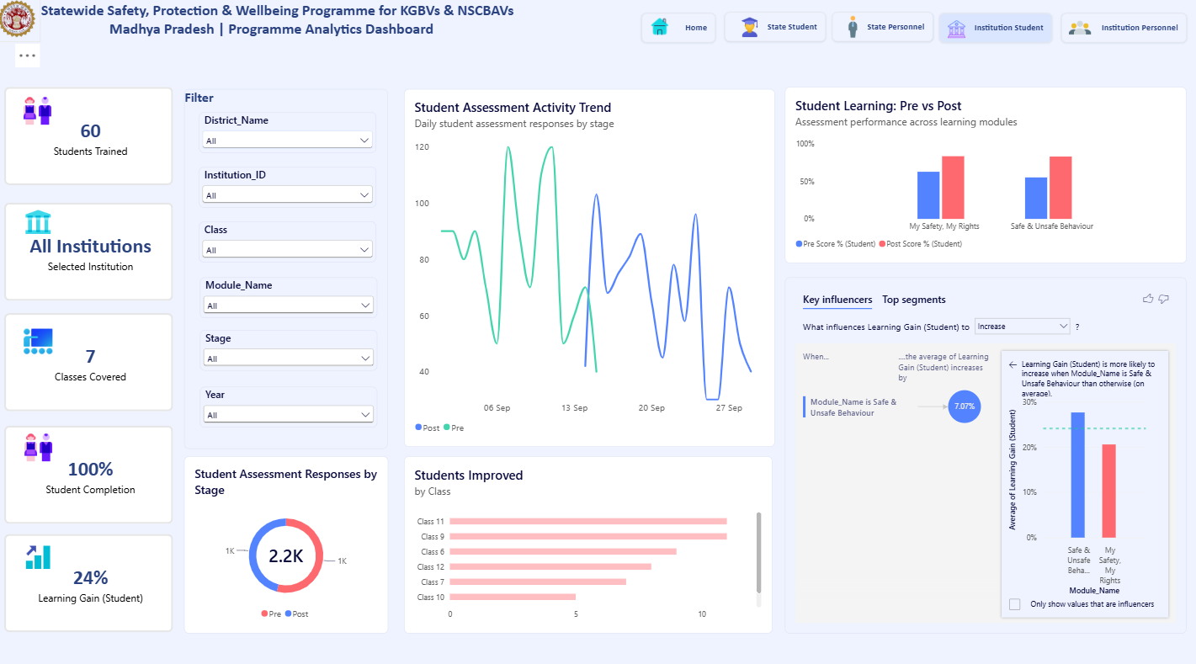
Page Overview
The Institution Student Analytics page provides a detailed view of student participation, assessment activity and learning outcomes at the selected institution level. It enables users to analyse student performance through pre- vs post-assessment scores, assessment activity trends, completion, class-wise improvement and module-level learning impact.
Interactive filters allow the analysis to be refined by district, institution, class, module, assessment stage and year. The page also uses Key Influencers to identify factors associated with changes in student learning gain.
Key focus:
Institution Selection → Assessment Activity → Student Performance → Learning Gain → Class-wise Improvement → Key Influencers

Visual: Student Assessment Activity Trend

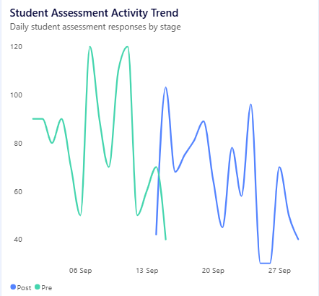

Purpose
The Student Assessment Activity Trend line chart shows the daily volume of student assessment responses, separated by Pre-Assessment and Post-Assessment stages.
Why It Is Used on This Page
This visual is used to understand when assessment activity occurred at the selected institution and how response volumes changed over the reporting period.
It helps stakeholders:
- Track assessment activity over time.
- Compare Pre vs Post assessment response patterns.
- Identify periods of higher or lower assessment activity.
- Understand the timing and distribution of assessment participation.
- Provide temporal context for the student learning and improvement metrics shown elsewhere on the page.
What Happens When Clicked
When a user selects a particular date or point on the trend:
- The selected assessment period is highlighted.
- Other connected visuals can be cross-filtered or highlighted, depending on the configured Power BI interactions.
- Users can investigate the corresponding student assessment performance and participation for that period.

Visual: Student Learning — Pre vs Post

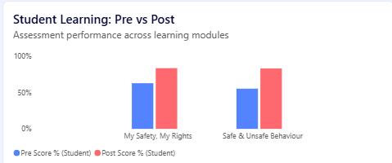

Purpose
The Student Learning: Pre vs Post clustered column chart compares student assessment performance before and after training across the learning modules My Safety, My Rights and Safe & Unsafe Behaviour.
Why It Is Used on This Page
This visual is used to assess the learning impact at the selected institution level. By displaying pre- and post-assessment scores side by side, it provides a clear view of the change in student performance following the training.
It helps stakeholders:
- Compare pre-training and post-training performance.
- Assess learning improvement across modules.
- Identify differences in outcomes between the two learning areas.
- Understand the assessment results of students within the selected institution.
In the current view, post-assessment scores are higher than pre-assessment scores for both modules.
What Happens When Clicked
When a user selects a module:
- The selected module is highlighted.
- Other connected visuals can be filtered or highlighted according to the configured Power BI interactions.
- The analysis can be further refined using the available district, institution, class, module, stage and year filters.

Visual: Key Influencers — Student Learning Gain

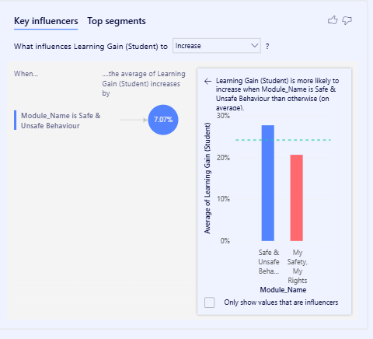
Purpose
The Key Influencers visual is used to identify factors that are associated with an increase in Learning Gain (Student). It uses Power BI's analytical capability to examine which attributes within the available data are linked with higher learning-gain values.
Why It Is Used on This Page
This visual adds a diagnostic layer to the institution-level dashboard.
While the other visuals show what happened—such as pre-vs-post performance and assessment activity—the Key Influencers visual helps investigate which factors may be associated with the observed learning gain.
In the current analysis, Module_Name = Safe & Unsafe Behaviour is identified as an influencer associated with a higher average Learning Gain (Student) than the overall average.
This should be interpreted as a statistical association identified by the Power BI visual, not as proof that the module caused the increase.
What Happens When Interacted With
Users can:
- Change the metric being analysed using the Increase selector.
- Review the identified influencing attributes.
- Select an influencer to examine the associated segment.
- Use the Top segments tab to explore notable combinations of attributes.
- Combine the analysis with the page's existing filters such as district, institution, class, module, stage and year.

Page 5 — Institution Personnel Analytics

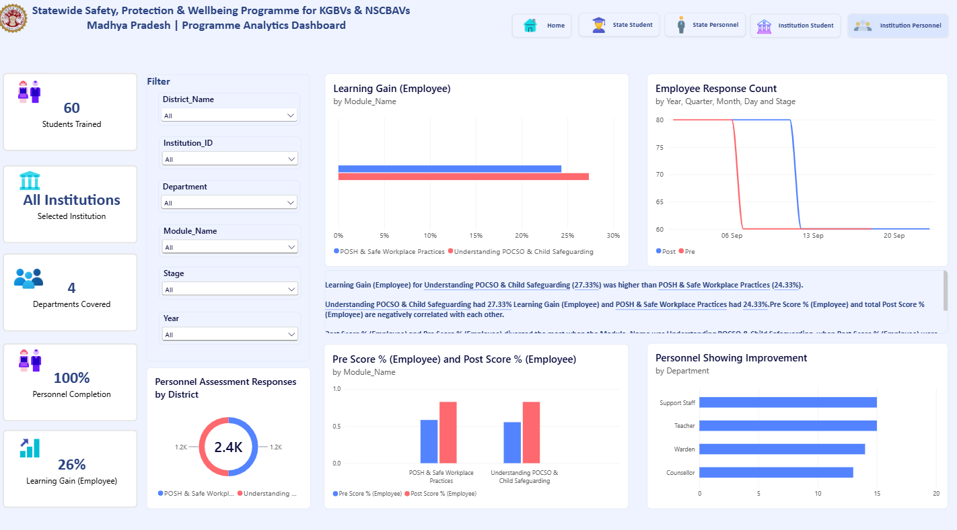
Page Overview
The Institution Personnel Analytics page provides a detailed view of personnel participation, assessment performance and learning outcomes at the institution level. It enables stakeholders to analyse personnel learning gain across modules, track assessment response activity, compare pre- and post-assessment scores, and identify improvement across different departments.
Interactive filters allow users to refine the analysis by district, institution, department, module, assessment stage and year.
Key focus:
Personnel Participation → Module-wise Learning Gain → Assessment Activity → Pre vs Post Performance → Department-wise Improvement

Visual: Learning Gain (Employee) by Module

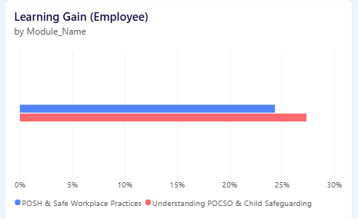
Purpose
The Learning Gain (Employee) by Module horizontal bar chart compares the learning gain achieved by personnel across the programme's learning modules:
- POSH & Safe Workplace Practices
- Understanding POCSO & Child Safeguarding
Why It Is Used on This Page
This visual provides a module-level view of personnel learning impact. While the overall KPI shows the combined learning gain, this chart breaks the measure down by individual learning areas.
It helps stakeholders:
- Compare learning gain across personnel modules.
- Identify modules with relatively higher or lower measured learning gain.
- Understand differences in learning outcomes between workplace-safety and child-safeguarding content.
- Provide context for the overall Learning Gain (Employee) KPI.
In the current view, Understanding POCSO & Child Safeguarding shows a higher measured learning gain than POSH & Safe Workplace Practices.
What Happens When Clicked
When a user selects a module bar:
- The selected module is highlighted.
- Other connected visuals can be cross-filtered or highlighted according to the configured Power BI interactions.
- Users can further examine the selected module through the pre/post assessment, response trend and department-level improvement visuals.
- The page filters can also be used to analyse the selected module by district, institution, department, stage or year.

Visual: Employee Response Count

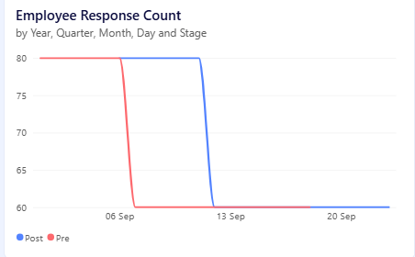
Purpose
The Employee Response Count line chart shows the number of personnel assessment responses over time, separated by Pre-Assessment and Post-Assessment stages.
Why It Is Used on This Page
This visual provides a time-based view of personnel assessment activity at the institution level. It helps stakeholders understand when personnel assessments were conducted and how response volumes changed between the pre- and post-assessment stages.
It helps to:
- Track personnel assessment activity over time.
- Compare Pre vs Post response patterns.
- Identify periods of higher or lower assessment activity.
- Provide temporal context for the personnel learning-gain and pre/post performance measures.
- Understand the assessment coverage underlying the reported learning outcomes.
What Happens When Clicked
When a user selects a particular date or point on the trend:
- The selected period is highlighted.
- Other connected visuals can be cross-filtered or highlighted according to the configured Power BI interactions.
- Users can investigate the corresponding personnel performance and assessment results for that period.

Visual: Personnel Assessment Responses by Module

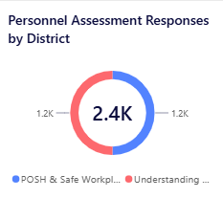
Purpose
The Personnel Assessment Responses by Module donut chart shows the distribution of personnel assessment responses across the programme's learning modules. The centre of the chart displays the total response volume of approximately 2.4K, while the two segments represent responses associated with:
- POSH & Safe Workplace Practices
- Understanding POCSO & Child Safeguarding
Why It Is Used on This Page
This visual provides a quick comparison of assessment response coverage across personnel learning modules.
It helps stakeholders:
- Understand the overall volume of personnel assessment responses.
- Compare response participation between the two learning modules.
- Assess whether the assessment dataset is distributed relatively evenly across modules.
- Complement the module-level Learning Gain (Employee) and Pre vs Post visuals.
This allows users to distinguish between how much assessment participation occurred and what learning outcome was observed.
What Happens When Clicked
When a user selects a module segment:
- The selected module is highlighted.
- Other connected visuals can be cross-filtered or highlighted according to the configured Power BI interactions.
- Users can then examine the selected module's learning gain, pre/post scores and personnel improvement.

Visual: Pre Score % (Employee) and Post Score % (Employee)

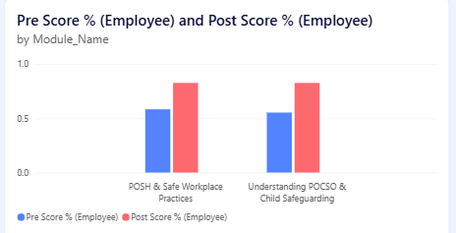
Purpose
The Pre Score % (Employee) and Post Score % (Employee) clustered column chart compares personnel assessment performance before and after training across the two learning modules:
- POSH & Safe Workplace Practices
- Understanding POCSO & Child Safeguarding
Why It Is Used on This Page
This visual provides a module-level assessment performance comparison and helps evaluate the change in personnel scores following training.
It allows stakeholders to:
- Compare pre-training and post-training performance.
- Measure the change in assessment scores for each module.
- Compare learning outcomes between personnel training modules.
- Support the interpretation of the overall Learning Gain (Employee) KPI.
In the current view, the post-assessment score is higher than the pre-assessment score for both modules, indicating an improvement in measured assessment performance.
What Happens When Clicked
When a user selects a module or one of the assessment bars:
- The selected module is highlighted.
- Other connected visuals can be cross-filtered or highlighted according to the configured Power BI interactions.
- Users can further analyse the selected module using the learning gain, response count and department-wise improvement visuals.
- Page-level filters can further refine the analysis by district, institution, department, stage and year.

Visual: Personnel Showing Improvement by Department
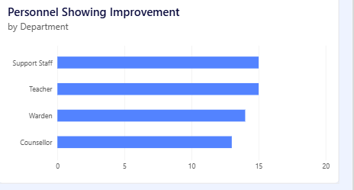
Purpose
The Personnel Showing Improvement by Department horizontal bar chart shows the number of personnel whose post-assessment score is higher than their pre-assessment score, broken down by department.
The current view covers four personnel groups:
- Support Staff
- Teacher
- Warden
- Counsellor
Why It Is Used on This Page
This visual provides a department-level perspective of personnel learning outcomes. While the overall Learning Gain KPI and module-level pre/post charts show aggregate performance, this visual helps identify how improvement is distributed across different personnel roles.
It helps stakeholders:
- Compare the number of improved personnel across departments.
- Understand differences in learning outcomes between personnel roles.
- Identify departments with relatively higher or lower numbers of personnel showing improvement.
- Support further investigation when combined with module and assessment-level analysis.
In the current view, Support Staff and Teachers have the highest number of personnel showing improvement, followed by Wardens and Counsellors.
What Happens When Clicked
When a department bar is selected:
- The selected department is highlighted.
- Other connected visuals can be cross-filtered or highlighted according to the configured Power BI interactions.
- Users can further analyse the selected department's pre/post scores, learning gain and assessment response activity.
- Additional page filters can be applied to examine the department by district, institution, module, stage or year.

